Scrub Bags / laundry Bags for Scrubs

Many nurses and care workers are now being asked to change at work from their uniform into their own clothes to travel home. Having a washable drawstring bag means that the dirty uniform can be put straight into the bag when a shift ends – and the bag and its contents can go straight into the washing machine.

You will need:

- 2 x pieces of cotton or polycotton washable fabric measuring approximately 52cm x 42 cm (21ins x 17ins)
This is a great way of upcycling old bedsheets or pillowcases – but wash at 60°C and iron before using.
- Sewing thread
- 50 cm (20 ins) ribbon or drawstring cord
- Safety pin

This will make a bag around the size of a school PE bag (50cm x 40 cm). The aim is for a bag large enough to fit a couple of items of adult clothing inside. You might want to make some larger bags for men to use.

Method:

1 Cut out 2x 55cm x 45cm pieces of fabric.

2 Pin the two pieces together with right sides facing and stitch around three sides of the bag using a 1.5cm (⅝ inch) seam allowance, pivoting with your needle at each corner.
WRONG SIDE
WRONG SIDE
RIGHT SIDE

WRON

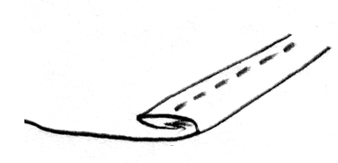
3 Keeping the bag inside out, turn over 1.5cm (⅝ inch) at the open end of the bag and iron. Then fold over another 3-4cm (1½ ins). This will form the casing for your drawstring, so if your ribbon or cord is quite wide, you may want to make this a deeper fold. Iron or pin the fold in place, then stitch around the top – leaving a gap of 5 cm (2 ins) to thread the ribbon or cord. This is probably best placed over one of the side seams.

WRONG SIDE

4 Thread the ribbon or cord through the casing by attaching the safety pin and pushing though the casing. If you have used ribbon, then hand stitch the ends together, or knot if you have used cord.

5 Turn the bag the right way – and you have a laundry bag for scrubs!

